# Control System Lab Lab 08



Submitted by**: Muhammad Sadeeq**

Registration Number**: 21pwcse2028**

Section: **C**

Submitted To**: Dr. Muniba Ashfaq**

December 1, 2024

# Department of Computer System Engineering University of Engineering and Technology Peshawar

Task 01

# Lab 08

**System Stability in Simulink**

Design a system in Simulink whose transfer function is as given below.

(𝑠) = 100

2

𝑠 +4𝑠+50

The input to the system is Unit Step for 8 seconds and output should be shown graphically. Design 3 system with complex poles such that first is stable. second is unstable and third is marginally stable. Show the results graphically.

**Simulink Block Design**

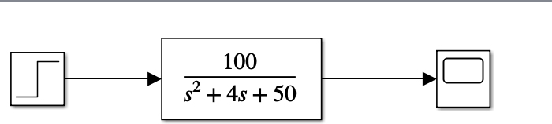

**Scope Result**

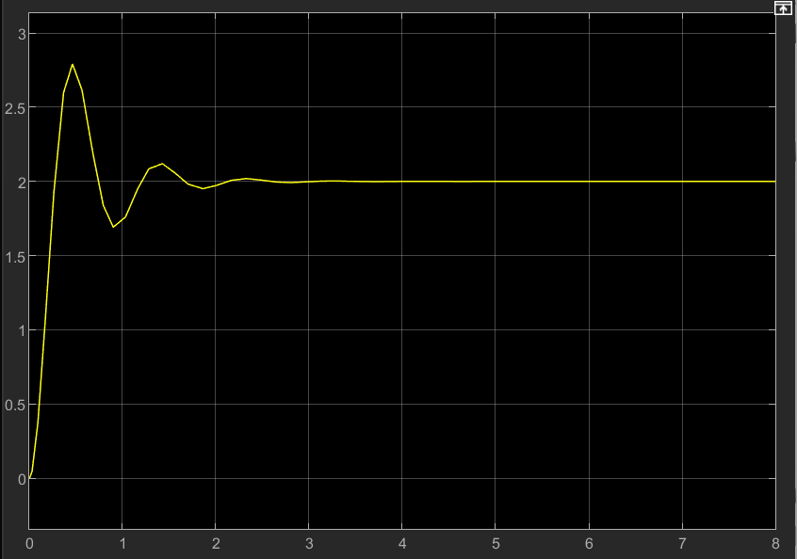

**MATLAB Coding**

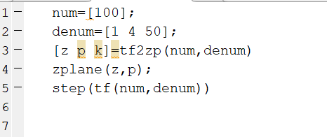

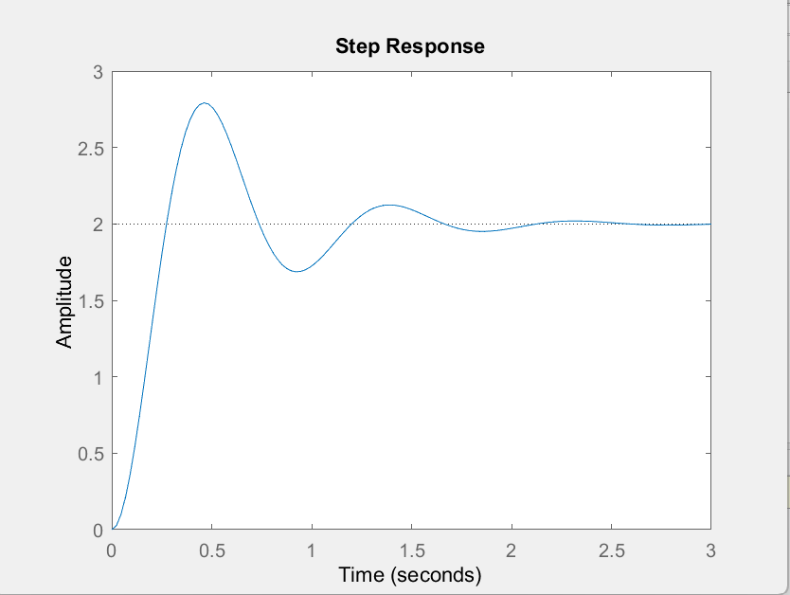

**Graphical view of Poles**

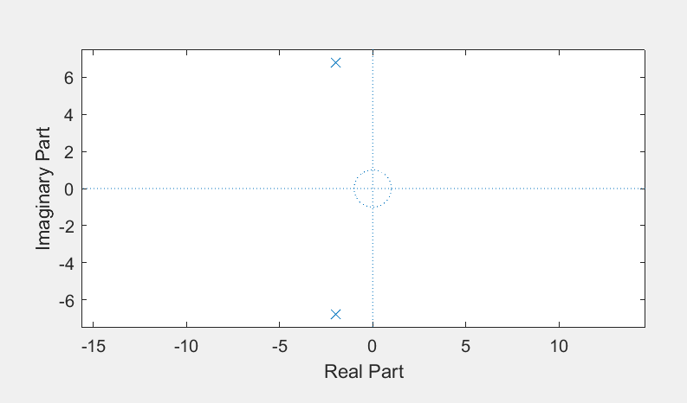

**Task 02**

**System 01: Stable**

**Simulink Block Design**

100

2

𝑠 +3𝑠+80

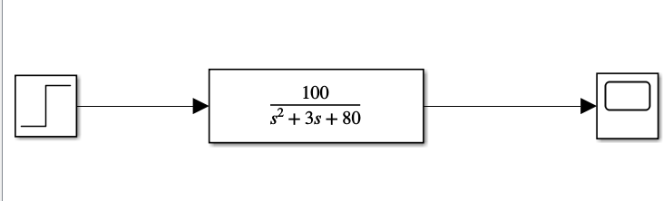

**Scope Result**

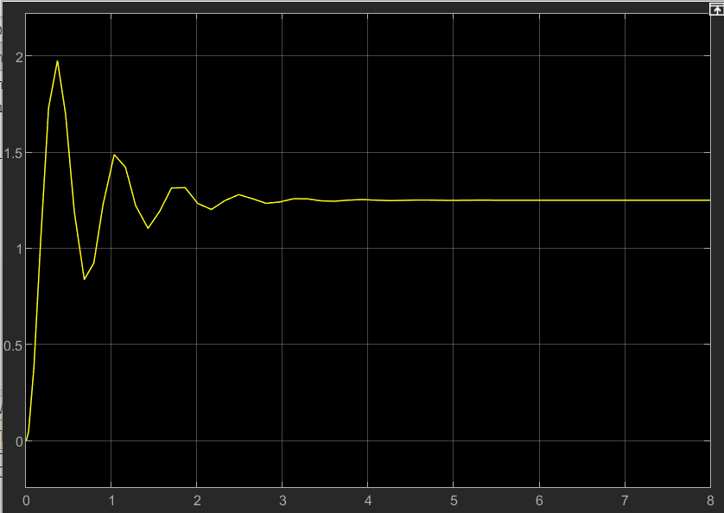

**MATLAB Coding**

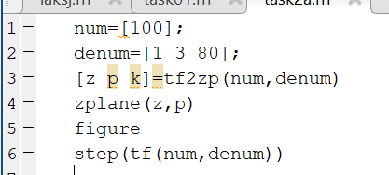

**Graphical view of Poles:**

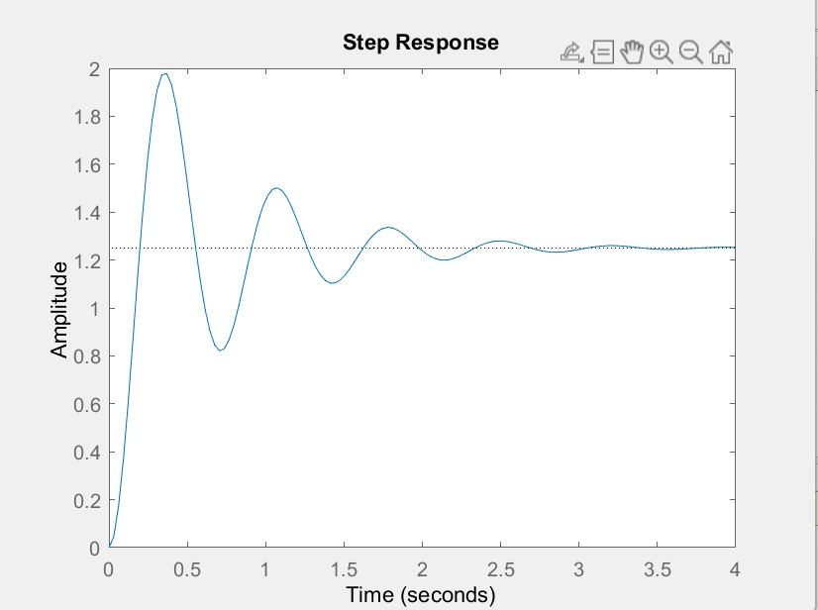

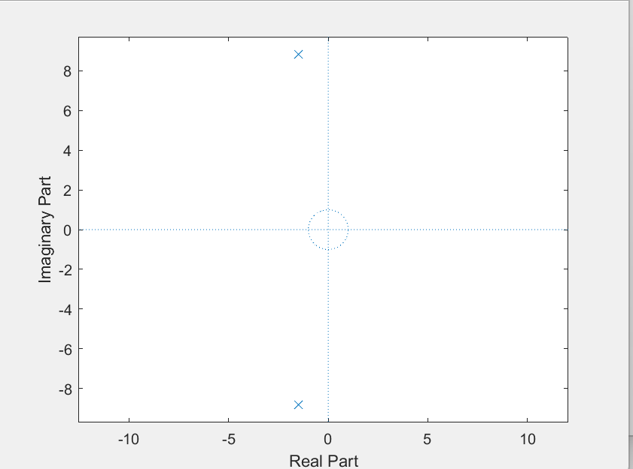

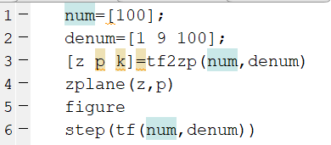

If poles are moving away from the real axis towards the left half of the complex plane, it generally indicates an improvement in stability. This is because the farther away the poles are from the imaginary axis, the faster the system response, which results in a more stable system.

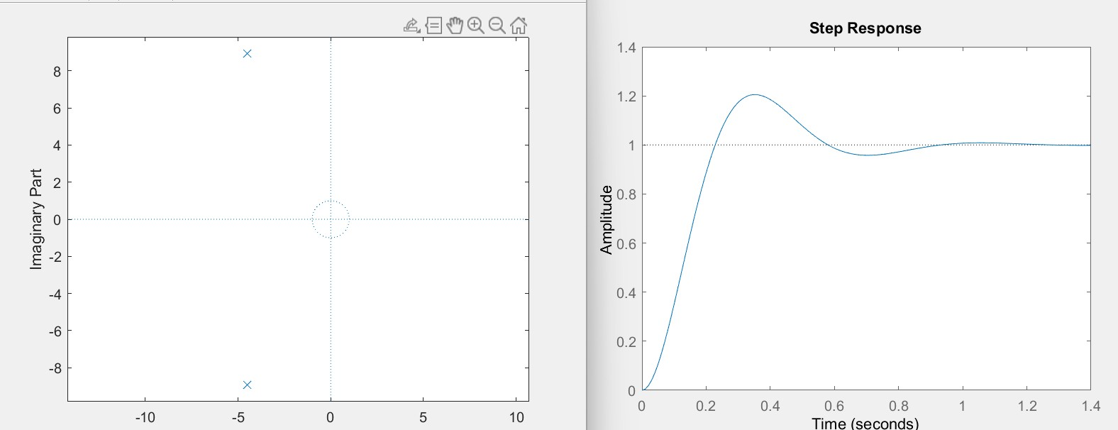

**Unstable System**

**Simulink Block Design**

100

2

3𝑠 −8𝑠+8

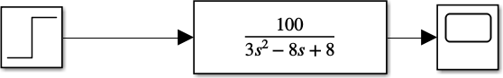

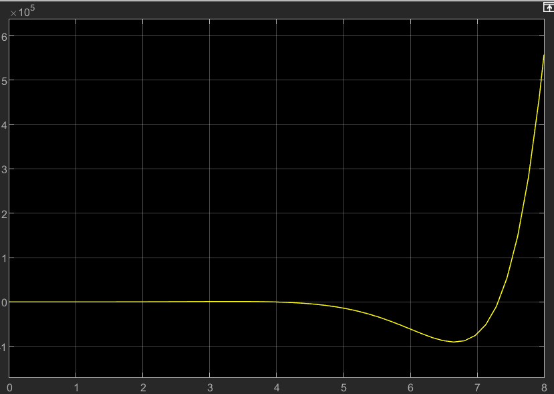

**MATLAB Coding**

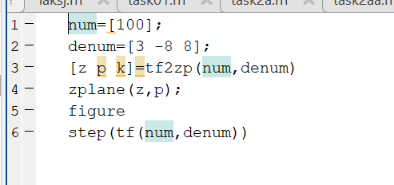

**Graphical view of Poles**

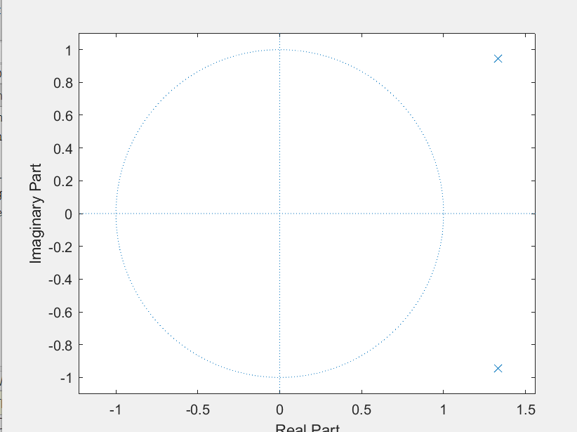

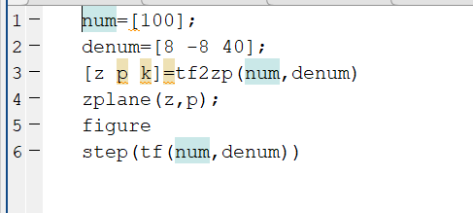

If the poles are moving towards the right-half of the complex plane (away from the real axis), it can lead to an unstable system. In an unstable system, the poles have positive real parts, and the system response grows without bound.

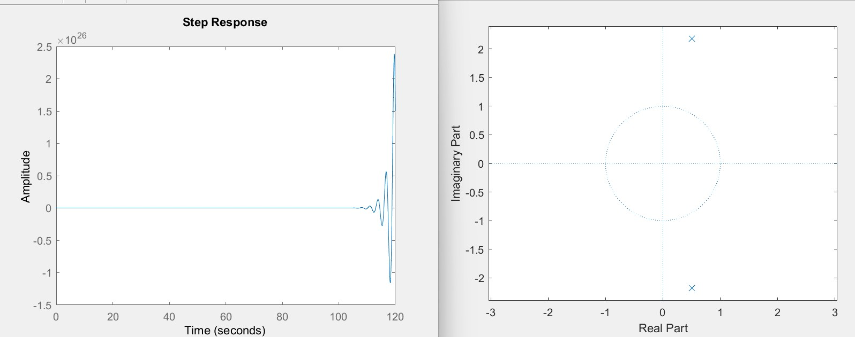

**Marginally Stable**

**Simulink Block Design**

1

2

3𝑠 +8

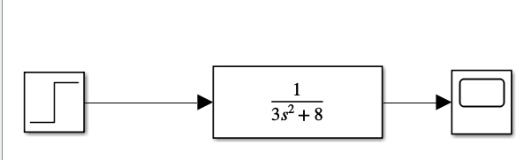

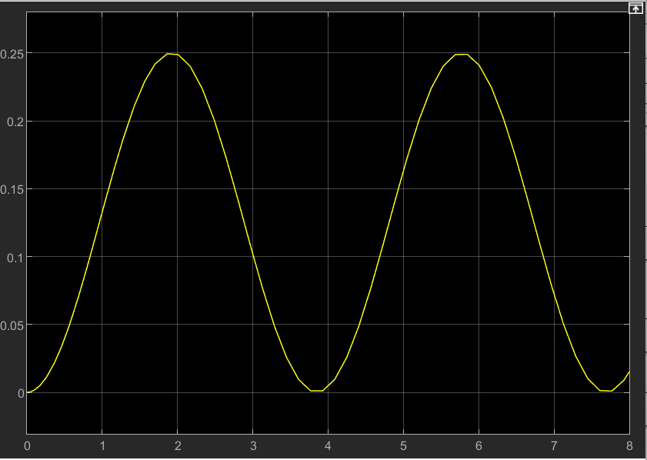

**Matlab Coding**

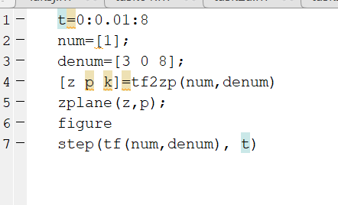

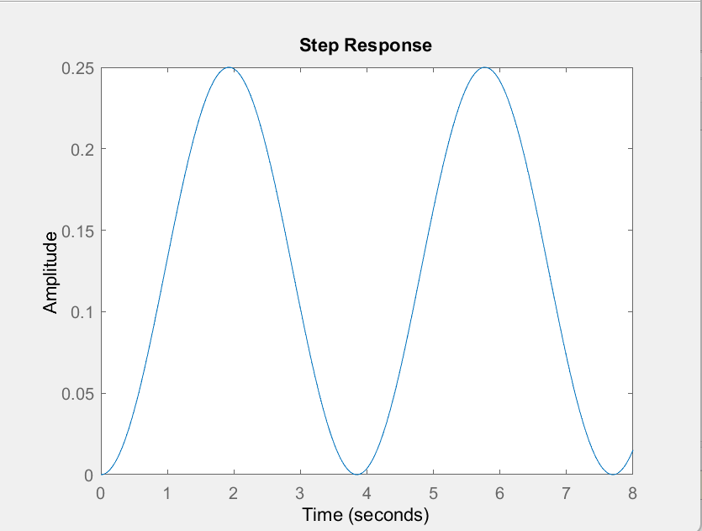

**Graphical view of poles**

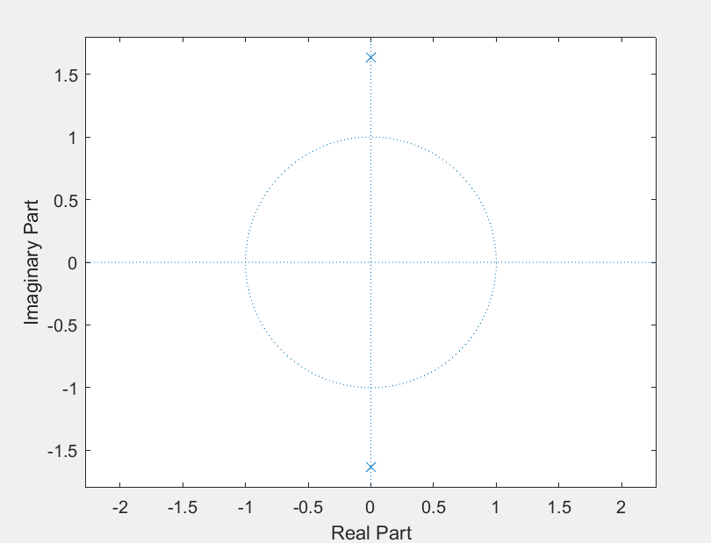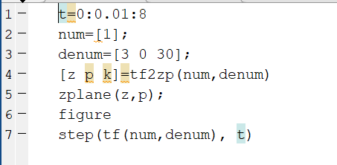

If the poles of a system are moving away from the origin along the imaginary axis in the complex plane, it typically indicates an increase in damping, and the step response sine wave will indeed shrink in amplitude.

